Document
Collecting
Documents
Clustering
Documents
Mapping
Technology
Forecasting
Figure 1 Flow of bibliometric analysis

Terms
Documents
Burt
Matrix
SVD
Perform Principal Component Analysis
Cluster
Similarity
Based on a similarity matrix
Figure 2 Flow of documents clustering

=
X

t*d

t*m

m*m

m*d

Figure 3 MatrixDecomposition of SVD
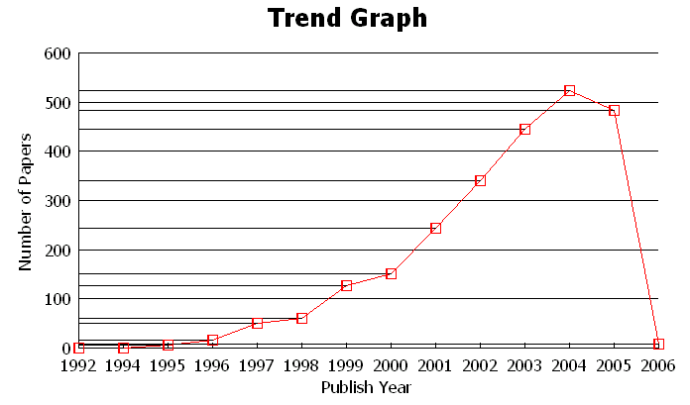
Figure 4 Trend of the number of papers
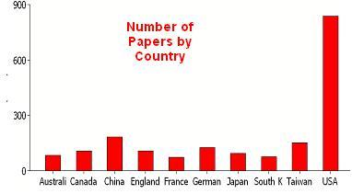
Figure 5 Distribution by country
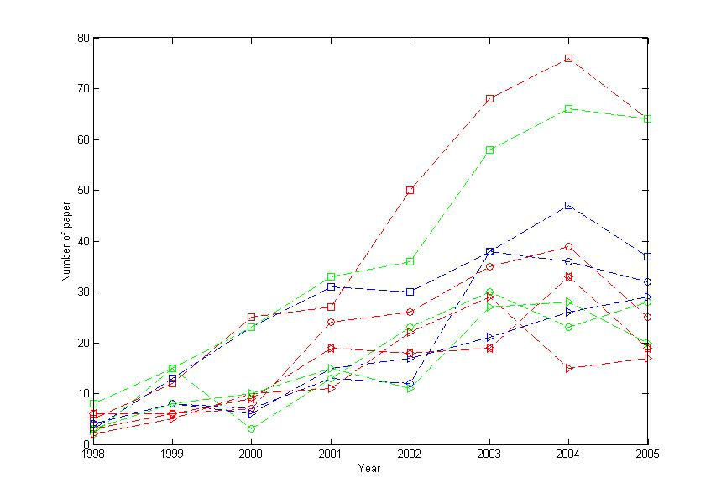
Figure 6 Trend of top ten topics during 1998-2005
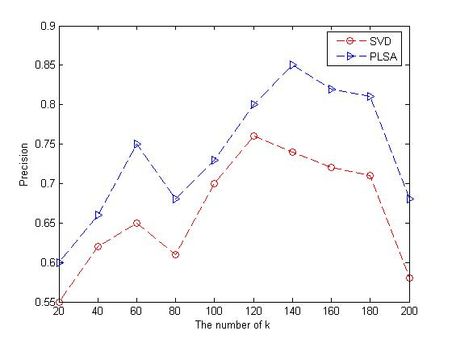
Figure 7 A comparison between PLSA and SVD

 | Topic words | Frequency
1 | Rough set | 332
2 | Neural network | 228
3 | Association rules | 212
4 | Genetic algorithm | 165
5 | Fuzzy logic/set | 157
6 | Decision trees | 141
7 | Machine learning | 135
8 | Regression | 129
9 | Data visualization | 114
10 | Support vector machine(SVM) | 105
Table 1 Topic frequency

